Jenkins pipeline

Pipeline:- pipeline as a code and it has set of stages and stages contains steps, steps will execute entire pipeline.

1. Declarative pipeline 2. Scripted pipeline

. In this pipeline we will write groovy script.

Stages example:-

Git clone (git checkout)

Build

Deploy

===================================

Scripted pipeline the code will start with node.

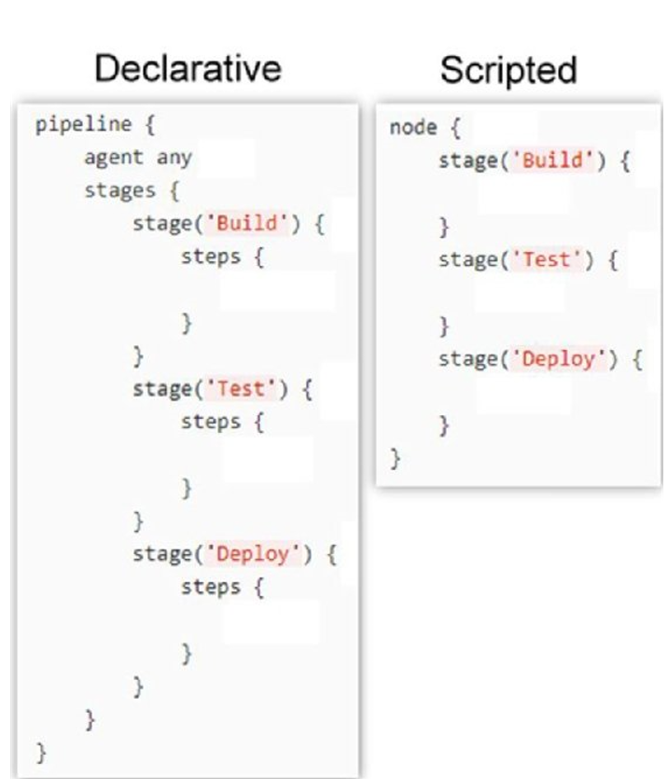

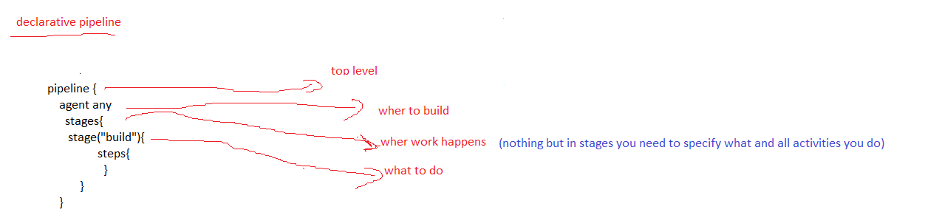

Pipeline🡺declarative pipeline

Pipeline🡺node🡺scripted pipeline

Agent :- any, none, label, docker

Jenkinsfile extention:- Jenkinsone or Jenkinsfile1 or Jenkins-123

1. Declarative pipeline:-

We will create Jenkinsfile in github.

Jenkinsfile1

pipeline {

agent any

stages{

stage (gitcheckout)

{

step ()

git clone url

{

stage (build)

mvn clean package

}

stage (deploy)

step ()

{

scp source destination

tomcat service start

}

}

2. scripted pipeline 🡺 it is write in Jenkins dash board.

node {

agent any

stages{

stage (gitcheckout)

{

step ()

git clone url

}

stage (build)

{

mvn clean package

}

stage (deploy)

step ()

{

scp source destination

tomcat service start

}

}

